D1.
- H₀: η_{a-o}=0 vs. H_{a}: η_{a-o}>0 where a=sample for Fentanyl alone and o=sample for Fentanyl w/other drugs
- 5, 5, 7, 10, 10, 11, 12, 13, 14, 15, 16, 19, 20, 25, 34, 62, 90, 120
1.5, 1.5, 3, 4.5, 4.5, 6, 7, 8, 9, 10, 11, 12, 13, 14, 15, 16, 17, 18
1.5+4.5+10+12+14+15+16+18=91
- W=U+$\frac{n(n+1)}{2}$ W-U=$\frac{n(n+1)}{2}$ 91-U=$\frac{8(8+1)}{2}$=36 U=91-36=55
- $\left({18 \atop 8}\right)=\frac{18!}{8!10!}=43758$
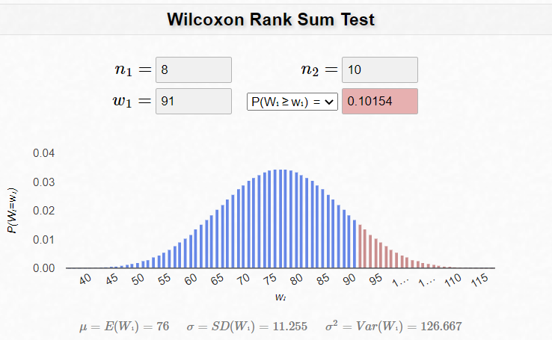

D2.
- There are m*n=10*8=80 Hodges differences associated with the data.
- Top row = other Left column = alone
 | 5 | 7 | 10 | 11 | 12 | 13 | 14 | 16 | 20 | 90
5 | 0 | -2 | -5 | -6 | -7 | -8 | -9 | -11 | -15 | -85
10 | 5 | 3 | 0 | -1 | -2 | -3 | -4 | -6 | -10 | -80
15 | 10 | 8 | 5 | 4 | 3 | 2 | 1 | -1 | -5 | -75
19 | 14 | 12 | 9 | 8 | 7 | 6 | 5 | 3 | -1 | -71
25 | 20 | 18 | 15 | 14 | 13 | 12 | 11 | 9 | 5 | -65
34 | 29 | 27 | 24 | 23 | 22 | 21 | 20 | 18 | 14 | -56
62 | 57 | 55 | 52 | 51 | 50 | 49 | 48 | 46 | 42 | -28
120 | 115 | 113 | 110 | 109 | 108 | 107 | 106 | 104 | 100 | 30
Median of Hodges differences = (8+9)/2=8.5
Median of fentanyl alone = (19+25)/2=22
Median of fentanyl w/other drugs = (12+13)/2=12.5
Fentanyl alone median – median of fentanyl w/other drugs = 22-12.5 = 9.5
The medians are close but not equal to each other.

- qwilcox(0.01,10,8,lower.tail=TRUE,log.p=FALSE)
[1] 14
qwilcox(0.01,10,8,lower.tail=FALSE,log.p=FALSE)
[1] 66
98% CI = (-6,49)
- of the Hodges differences are excluded from each end of the confidence interval.
D3.
- Ranks for alone: 1.5, 4.5, 10, 12, 14, 15, 16, 18 total=91 average=91/8=11.375
Ranks for other: 1.5, 3, 4.5, 6, 7, 8, 9, 11, 13, 17 total=80 average=80/10=8
Success rate for alone {1,2,7,8,9,9,9,10} total=55 average=55/8=6.875 (p bar)
Success rate for other {1,1,2,2,2,2,2,3,4,7} total=26 average=26/10=2.6 (q bar)
- falone<-c(5,10,15,19,25,34,62,120)
fother<-c(5,7,10,11,12,13,14,16,20,90)
pFligPoli(falone,fother,method=”Exact”)
Number of X values: 8 Number of Y values: 10
Fligner-Policello U Statistic: -1.3028
Exact upper-tail probability: 0.9014
Exact two-sided p-value: 0.1973
- The rank-sum test assumes equal variances. The Fligner-Policello test assumes unequal variances and symmetric distributions. The variances are not equal and the distributions are not symmetric.
D4.
- Joint sample median = (14+15)/2=14.5

 | Success | Fail | total
Alone | 6 | 2 | 8
Other | 3 | 7 | 10
total | 9 | 9 | 18
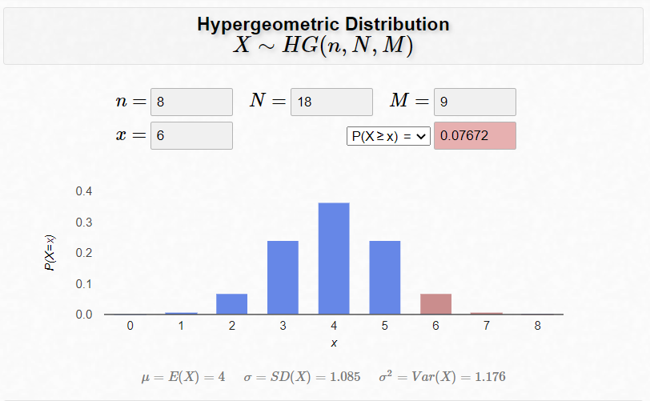

- The two-sample t-test is less appropriate than Mood’s median test for this data set since it is not resistant to outliers and each of the samples contain outliers.

